1. Create a function module to import a range of customer numbers and export the customer data for the given range.

Customer Data can be found in table KNA1.

Time : 30 minutes

Create a package and keep all objects created for this task in that package.

Paste screenshots of all the objects created for this task.

**Package name : ZUST_180496**

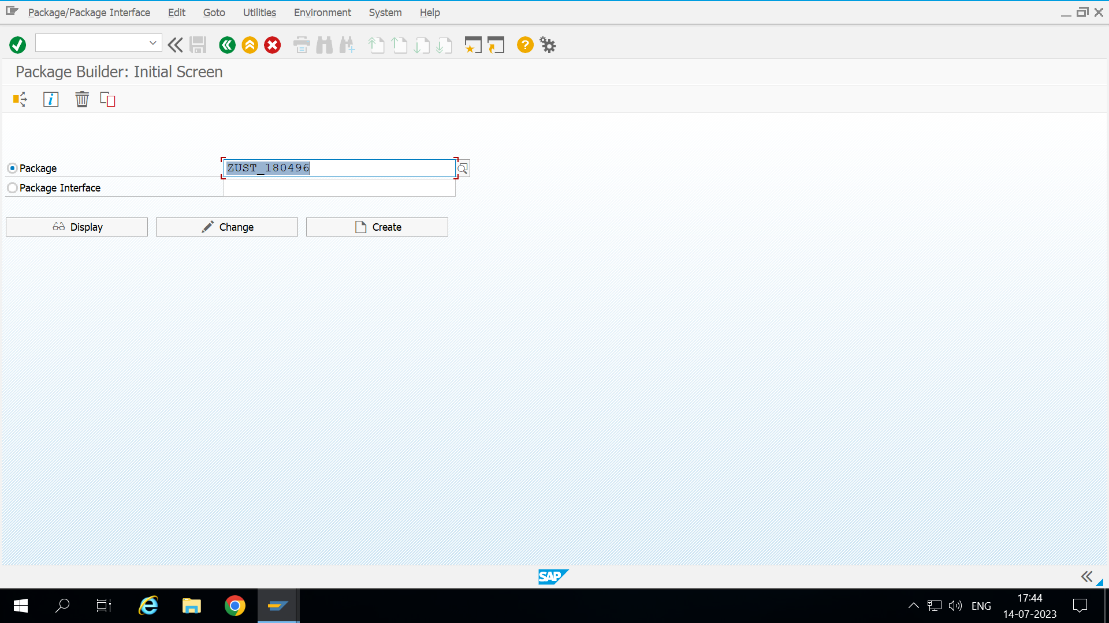

**Executable program : [zcustomer_data_180496]**

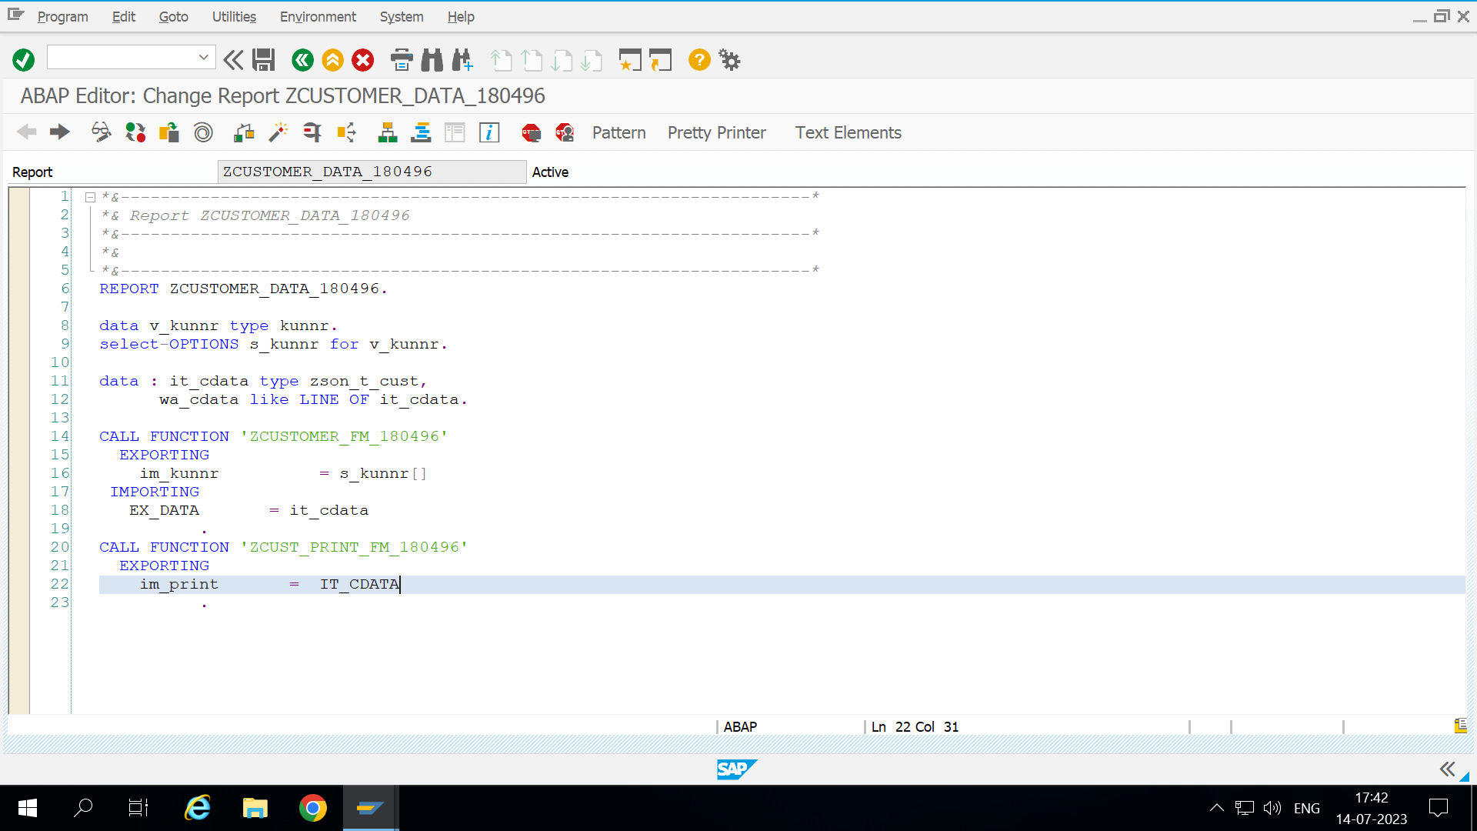

**Function module 1 : zcustomer_fm_180496**

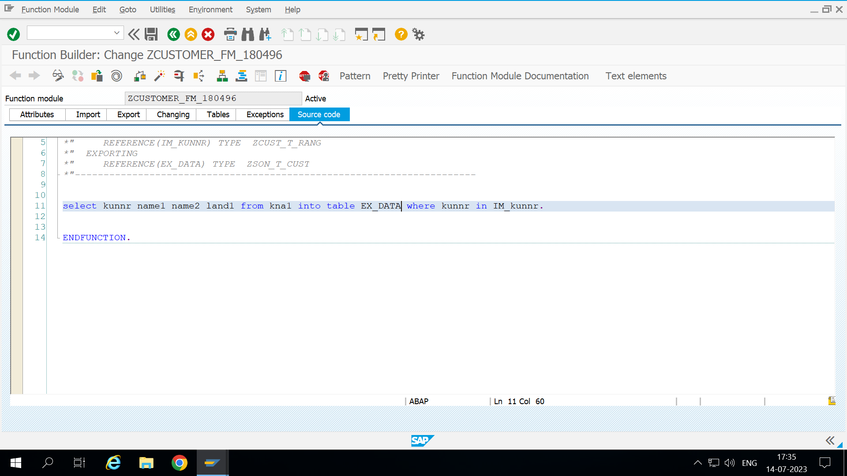

**Function module 2 : zcust_print_fm_180496**

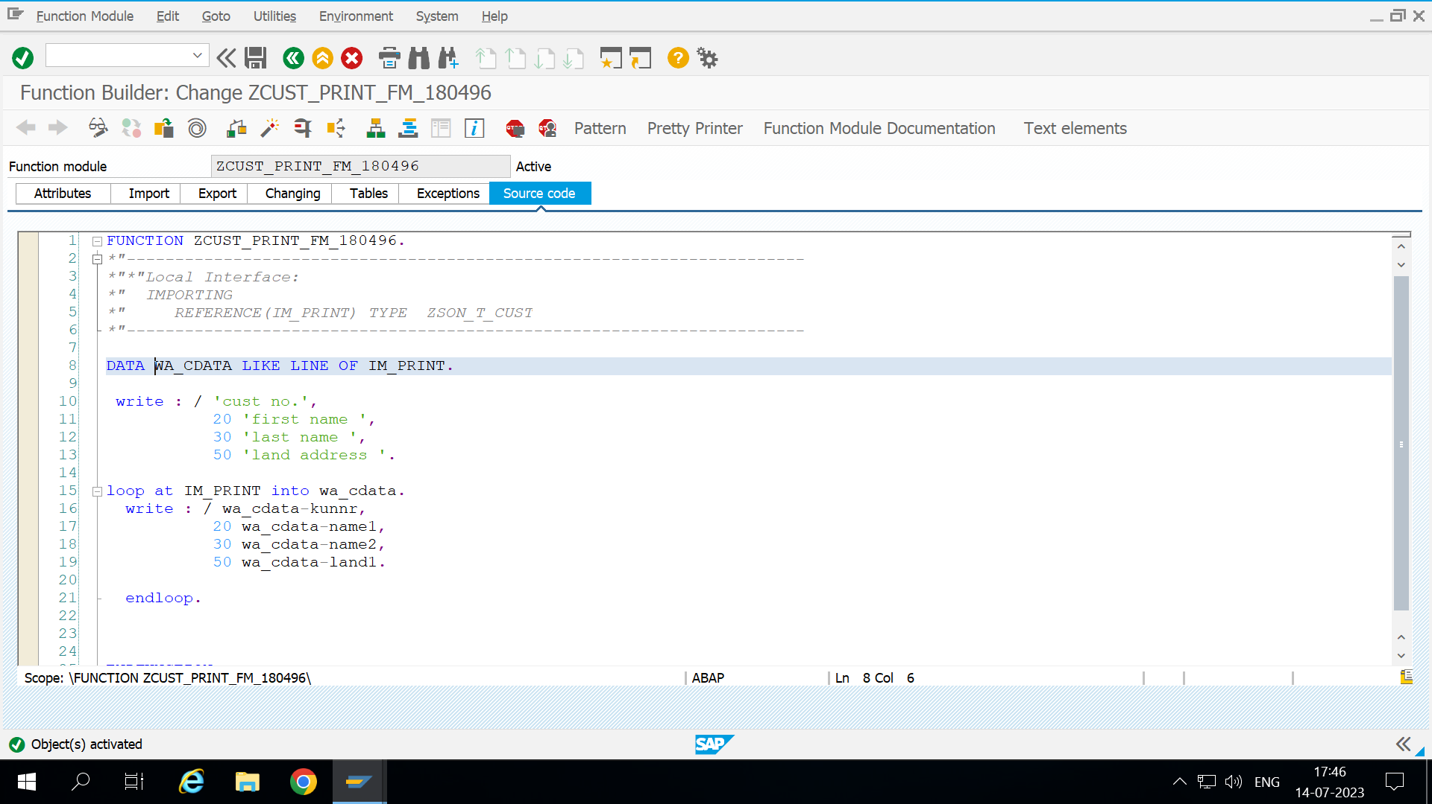

**Output**

